Callie Causey

Processing Manager
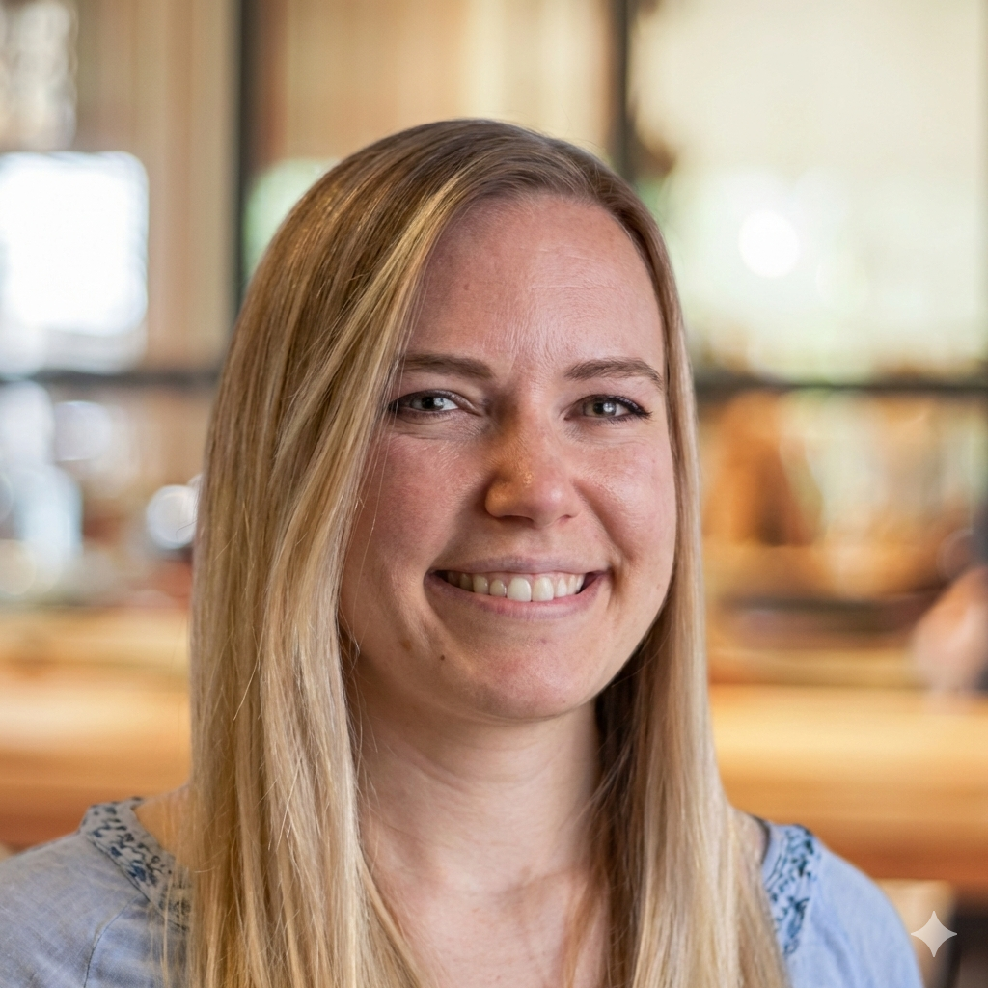
Callie is the expert behind the scenes who helps make sure your mortgage file is ready for approval. As our Processing Manager, she prepares and reviews every document needed to move your home loan forward quickly and accurately. Callie works closely with underwriters, clients, and our internal team to meet lending guidelines, clear conditions, and keep your loan on track. Her experience and dedication to detail help reduce delays and ensure a stress-free process. Whether you’re buying a home or refinancing, Callie plays a critical role in getting you to the finish line with confidence.

